Developing the SMART-ACE Framework: Social Media Analytics and Research Translation to Advance Children’s Environmental Health
Supplemental Materials
Version Date: May 29, 2025
Additional project details are available at the GitHub Repository https://github.com/larkinandy/ChildrensHealthSocialMediaASP3IRE

Table of Contents
Supplemental Appendix 1. Querying the X Developer API…………………………………………… 2
Supplemental Table 1. Number of Posts Downloaded for Each Keyword………..………………… 3
Supplemental Appendix 2. Deep Learning Model Architecture……………………………………… 5
Supplemental Figure 1. Deep Learning Model Architecture…………………………………………. 5
Supplemental Table 2. Frequency of Sampled Keywords to Create Labeled Dataset………….. 6
Supplemental Figure 2. Social Media Labeling Website………………………………………..……. 7
Supplemental Appendix 1. Example Training Materials for Social Media Labelers. ………………. 8
Supplemental Table 3. Emojis Added to the Bidirectional Encoder Representations from Transformers Word Embedding Dictionary…………………………………………………………………………………….. 9
Supplemental Figure 3. Preprocessing Imagery for the Age Multimodal Deep Learning Model….. 10
Supplemental Table 4. City Shortnames Used in Named Entity Recognition………………………… 11
Supplemental Table 5. Composition of User Profile Arrays…………………………………………… 12
Supplemental Table 6. Percent Positive Labels in Labeled Datasets, Stratified by Keyword….…... 13
Supplemental Table 7. Student Labeling QA Accuracy for Summer 2022………………………….... 15
Supplemental Table 8. Student Labeling QA Accuracy for Fall 2022…………………………………. 16
Supplemental Table 9. Student Labeling QA Accuracy, Stratified by Student, Label, and Model….. 17
Supplemental Table 10. Validation Dataset Performance Metrics for Age Deep Learning Models…. 18
Supplemental Table 11. Validation Dataset Performance Metrics for Place Deep Learning Models… 19
Supplemental Table 12. Validation Dataset Performance Metrics for Health Deep Learning Models… 20
Supplemental Table 13. Number of Georeferenced Posts, Stratified by Georeferencing Method……. 21
Supplemental Table 14. Community Summary Statistics, Stratified by Community Size…………….. 22

Supplemental Appendix 1. Querying the X Developer API.

Six hundred and eighty-five million posts were downloaded from the social media platform X by querying the X Developer API. Inclusion criteria were:
- original posts, replies, quotes, or retweets with comment. Retweets without added comment were excluded.
- creation date between January 1st, 2014 (inclusive) to February 18th, 2023 (inclusive)
- text contained one or more keywords relevant to children’s environmental health (Supplemental Table 1)
- content was publicly viewable
- country of origin was the United States, and
- language was English
Data returned from API queries were:
- Post text
- Creation timestamp
- Author id
- Conversation id
- Author self-reported home town/city (optional)
- Approximate location via geofence or point of interest (optional)
- Attached images or first frame of video (optional)
- Replied to and/or referenced X usernames and ids (optional), and
- Preceding post id (if post was a reply, quote, or retweet with comment)

.

Supplemental Table 1. Number of posts downloaded for each keyword.
Age |  | Place |  | Health |  | Health (cont'd) |  | Health (cont'd) |  | Exposure
keyword | n | keyword | n | keyword | n | keyword | n | keyword | n | keyword | n
anklebiter | 138 | academy | 679948 | accident | 4529978 | empathy | 305669 | rash | 62483 | air | 2954010
babe | 2973574 | after school care | 4542 | activity | 559889 | encourage | 442060 | read | 9690610 | anthropogenic | 1405
babies | 1558445 | apartment | 1250306 | ADD | 3407580 | enjoy | 6364392 | reading | 3666738 | antibiotics | 50072
baby | 16018186 | backyard | 401044 | adjustment | 73566 | excited | 9582513 | reason | 7221319 | arsenic | 9570
bambino | 7364 | center-based care | 22371 | aerobic | 9148 | exhaustion | 70323 | relationships | 1064534 | cadmium | 673
boy | 10317369 | childcare | 39955 | affection | 157735 | express | 982519 | remember | 10611450 | carbon monoxide | 11119
brat | 227427 | community | 3251829 | aggression | 95387 | externalizing | 449 | risk-taking | 2772374 | chemicals | 59899
bundle of joy | 16650 | condo | 158524 | allergy | 114648 | feeling | 8698939 | running | 5745146 | fracking | 54678
child | 3487635 | condominium | 15845 | altered immune system | 10 | flexibility | 77588 | sad | 9438824 | haze | 188860
childhood | 696744 | court | 2137465 | anger | 640231 | focus | 1989641 | self-control | 2616758 | heavy metal | 33495
children | 3253691 | day camp | 44329 | anxiety | 1280396 | food | 10270124 | self-esteem | 1504157 | lead | 2980827
girl | 20909988 | day nursery | 2474 | anxious | 352226 | friends | 18258848 | self-regulation | 1543733 | mercury | 116215
high schooler | 23220 | daycare | 117737 | appropriate | 545383 | giggle | 128256 | share | 4659780 | noise | 572534
in elementary school | 150518 | digs | 65276 | arithmetic | 12224 | happy | 45798586 | SIDS | 8122 | oil drilling | 4527
infant | 86796 | early childhood center | 2716 | asthma | 108983 | heart | 10267482 | smart | 2739796 | pesticide | 7805
juvenile | 345 | early education | 16721 | attention | 3349284 | heat | 2477823 | social | 4805985 | pollution | 72550
kid | 5610084 | early education center | 1079 | behavior | 981747 | heat exhaustion | 7580 | solving | 131097 | radon | 2712
kiddie | 29303 | early learning center | 3864 | bone | 573321 | hyperactive | 4790 | speech | 1895072 | smoke | 2823599
little one | 351367 | education center | 15172 | brain | 2187954 | hyperactivity | 1413 | thinking | 8209626 | tobacco | 105427
middle schooler | 17692 | elementary | 680410 | breathe | 947861 | identity | 405238 | understand | 7540584 | vaping | 60415
minor | 464009 | field | 3412914 | calm | 1215949 | imagination | 234891 | weight | 1760389 | water | 4617638
neonate | 430 | front yard | 70414 | cancer | 1534255 | impulsivity | 1705 | wheeze | 5791 | wildfire | 55636
newborn | 108463 | greenspace | 2597 | cardiovascular | 17348 | injury | 939096 | write | 2410598
pediatric | 58865 | home | 22914915 | cerebral palsy | 11684 | intelligence | 536810
preemie | 4688 | home-based care | 142271 | cognition | 9541 | intelligent | 447208
preschooler | 5998 | house | 13975833 | cognitive | 104150 | interaction | 173746
preterm | 1802 | jungle gym | 6119 | communicate | 251545 | internalizing | 2897
pupil | 12413 | kindergarten | 201566 | community | 4095555 | knowledge | 1072412
rug rat | 488 | learning center | 33401 | compassion | 356106 | language | 1087167
teenager | 211801 | merry go round | 10408 | conflict | 254154 | learn | 5360454
toddler | 211958 | middle | 3411911 | connect | 806481 | learning | 2605913
tot | 52585 | nannie | 4661 | cooperate | 60127 | leukemia | 31119
tyke | 3667 | nanny | 111082 | coordination | 49971 | literacy | 143112
youngling | 1604 | neighbor | 554744 | cope | 140264 | lonely | 961587
youth | 1015107 | neighborhood | 922815 | cough | 473810 | lungs | 258917
 |  | nursery | 56253 | covid | 2792254 | manners | 129687
 |  | nursery school | 2671 | creativity | 324445 | math | 1535504
 |  | pad | 244095 | critical | 583956 | memory | 995643
 |  | park | 7451994 | crying | 4718752 | metacognition | 2858
 |  | parkland | 74572 | curriculum | 140453 | mind | 9205648
 |  | play area | 11315 | deficit | 181033 | misbehaving | 10850
 |  | playground | 166699 | dehydration | 23274 | mitochondrial dysfunction | 90
 |  | playschool | 284 | delay | 1740481 | muscle | 453907
 |  | prekindergarten | 776 | depressed | 628472 | nervous | 1079270
 |  | preschool | 94969 | developmental | 33382 | nutrition | 245198
 |  | recreational area | 1462 | developmental toxicity | 15 | obesity | 75352
 |  | rental | 230410 | diabetes | 285369 | peer | 149399
 |  | residence | 145880 | diet | 778034 | phocomelia | 25
 |  | respite care | 799 | disability | 178173 | physical | 875025
 |  | school | 18922038 | disorder | 176454 | playing | 10135892
 |  | schoolhouse | 13579 | disruptive | 42393 | pleasant | 413471
 |  | schoolyard | 8895 | dizzy | 120956 | posture | 53826
 |  | seesaw | 27486 | dyspraxia | 346 | problem | 5688307
 |  | swings | 129022 | emotional | 1345396 | psychological | 4
 |  | townhouse | 29812 | emotions | 881177 | pyrethroid | 34

Supplemental Appendix 2. Deep Learning Model Architecture.
Deep learning model structures differed based on the domain (age, place, health) and whether a social media post included an image (text vs. multimodal models, Supplemental Figure 1).
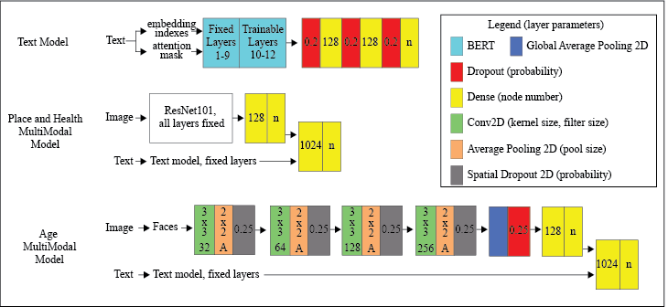
Supplemental Figure 1. Deep Learning Model Architectures. Abbreviations: n – number of multi-label classifications (n=6,7, and 5 for age, place, and health domains, respectively). Layer names in the legend conform to Tensorflow nomenclature. Non-default layer parameters passed as input arguments are shown in their respective layer boxes.
For all deep learning models, text inputs were passed through a pre-trained bidirectional encoder representations from transformers (BERT) model (BERT base model, uncased). Text preprocessing included transforming text into attention masks and BERT dictionary word-level embedding indexes. The base BERT dictionary was appended with embeddings for the 100 most frequent emojis within downloaded posts (Supplemental Table 3). BERT layers 1-9 were frozen, while layers 10-12 were trainable. BERT pooler output layers were appended with three fully connected layers interspersed with dropout layers to convert BERT decoding outputs to multi-label classifications.
Place and health multimodal models consisted of first passing imagery and text through separate pre-trained layers (Residual Networks, aka ResNet 101 model for imagery and pre-trained text models for text) then joining layer outputs through two fully connected layers. For the age domain multimodal model images were preprocessed by first cropping faces from social media imagery using the multi-task cascaded convolutional neural network (MTCNN) model (Supplemental Figure 2). Clipped faces were then passed through several blocks of convolutional, pooling, and spatial dropout layers, with gradually increasing convolutional filter size (range = 32 to 256). Convolutional layers were pretrained to classify age groups from faces using the publicly available All-Age-Faces and UTKFace datasets. For social media imagery with multiple faces, multimodal predictions were aggregated by taking the maximum probability estimate for each class before applying the SoftMax algorithm to derive multi-class classifications.
Supplemental Table 2. Frequency of Sampled Keywords to Create Labeled Dataset.
Age |  | Place |  |  |  | Health
keyword | n | Keyword | n | keyword | n | keyword | n | keyword | n
anklebiter | 29 | academy | 832 | kindergarten | 1024 | accident | 601 | injury | 629
babe | 1661 | ADD | 803 | learning center | 683 | activity | 653 | intelligence | 627
babies | 1426 | after school care | 294 | leukemia | 776 | aerobic | 396 | intelligent | 623
baby | 1481 | allergy | 691 | merry go round | 598 | allergy | 635 | knowledge | 687
bambino | 1119 | apartment | 725 | middle school | 765 | arithmetic | 312 | learn | 660
boy | 1408 | backyard | 1080 | nannie | 253 | asthma | 622 | learning | 792
brat | 1467 | cancer | 822 | nanny | 846 | attention | 644 | leukemia | 892
bundle of joy | 1656 | center-based care | 643 | neighborhood | 812 | bone | 691 | lungs | 635
child | 1563 | childcare | 662 | neighborhood | 772 | brain | 651 | memory | 697
childhood | 1772 | community | 832 | nursery | 861 | breathe | 668 | mind | 612
children | 1540 | condo | 800 | nursery school | 95 | cancer | 782 | muscle | 713
elementary school | 1288 | condominium | 613 | pad | 791 | cardiovascular | 554 | nutrition | 782
girl | 1354 | coordination | 664 | park | 777 | cognition | 224 | obesity | 884
high schooler | 1136 | court | 772 | parkland | 649 | coordination | 668 | palsy | 600
infant | 1362 | day camp | 762 | play area | 556 | cough | 642 | phocomelia | 2
juvenile | 61 | day nursery | 111 | playground | 850 | creativity | 836 | physical | 624
kid | 1395 | daycare | 822 | playschool | 6 | critical | 702 | playing | 677
kiddie | 1332 | dehydration | 625 | posture | 697 | curriculum | 718 | posture | 734
little one | 1760 | digs | 913 | prekindergarten | 44 | deficit | 669 | problem | 639
middle schooler | 1115 | dyspraxia | 6 | preschool | 1062 | dehydration | 590 | rash | 660
minor | 1293 | early childhood center | 327 | rash | 712 | delay | 599 | read | 741
neonate | 34 | early education | 707 | recreational area | 45 | developmental | 588 | reason | 676
newborn | 1618 | early education center | 98 | rental | 806 | diabetes | 824 | running | 651
pediatric | 1442 | early learning | 201 | residence | 726 | diet | 709 | SIDS | 592
preemie | 467 | education center | 629 | respite care | 24 | disability | 708 | smart | 657
preschooler | 716 | elementary | 790 | school | 708 | disorder | 651 | solving | 792
preterm | 142 | field | 814 | schoolhouse | 386 | dizzy | 607 | thinking | 611
pupil | 1135 | flexibility | 710 | schoolyard | 287 | dyspraxia | 12 | understand | 620
rug rate | 96 | front yard | 1111 | seesaw | 175 | exhaustion | 612 | weight | 638
teenager | 1257 | greenspace | 66 | SIDS | 320 | flexibility | 736 | wheeze | 256
toddler | 1599 | heat exhaustion | 114 | swings | 729 | food | 665 | write | 645
tot | 1558 | home | 723 | townhouse | 662 | heart | 685
tyke | 753 | home-based-care | 681 |  |  | heat | 676
youngling | 187 | house | 740 |  |  | hyperactivity | 114
youth | 1772 | jungle gym | 471 |  |  | imagination | 681

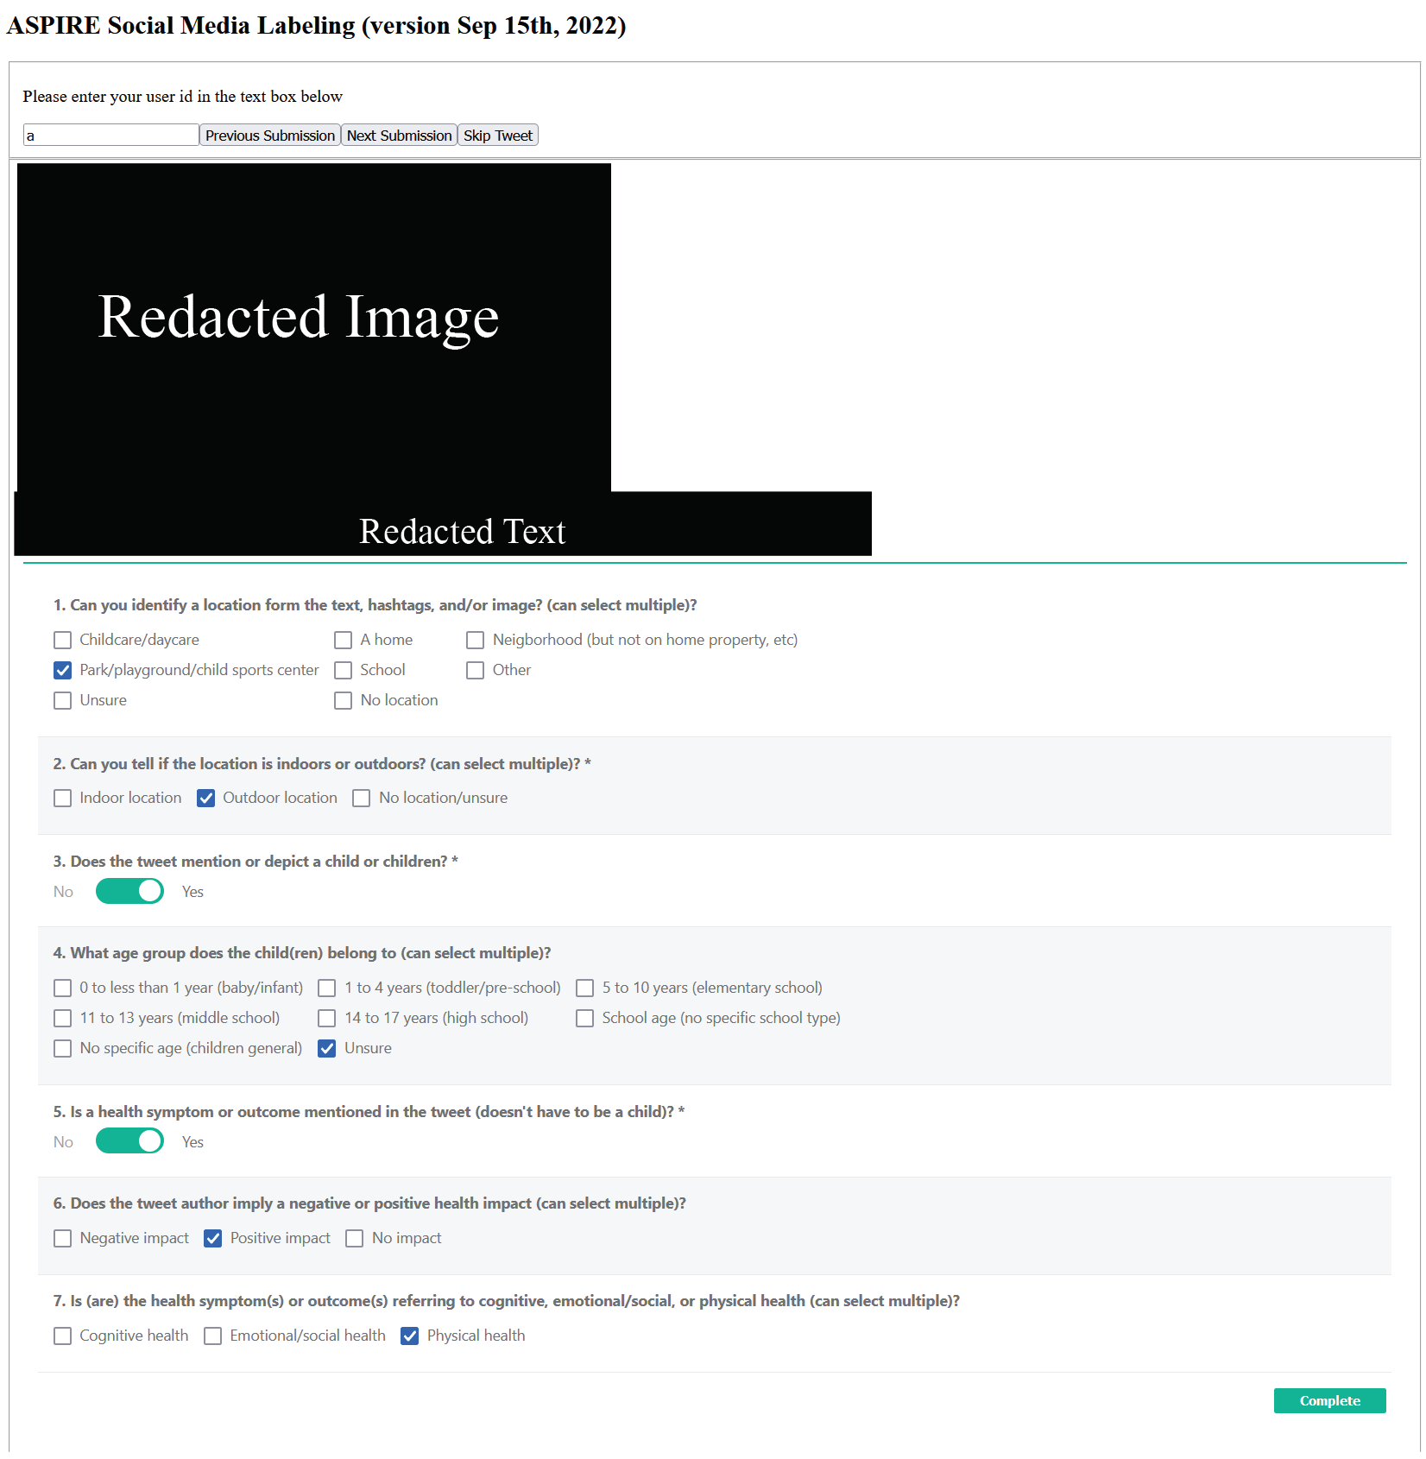
Supplemental Figure 1. Social Media Labeling Website. Trained workers labeled posts using checkboxes and toggle buttons.

Supplemental Appendix 1. Example Training Materials for Social Media Labelers.

Does this tweet mention or depict a child or children (yes/no)?
Directions: Look at the username, text, hashtags, and image. Does the text, hashtags, or image mention or depict a child or children? Descriptions or depictions of related nouns such as schools, pediatricians, and toys do not count. The text, hashtags, or image must either directly mention or depict a child or a group of children. Images which include children as part of a meme, metaphor or fictional works such as movies do not count. Images of prengnant women, ultrasounds, baby showers, and other examples of prebirth content do not count as a baby.

Options
No: the text and/or image do not directly mention or depict a child. (3.3,3.4)
Yes: the text and/or image directly mentions or depicts a child. (3.1,3.2)


Question 3 Example Answers
3.1 Answer: Yes
3.1 Explanation: While the text does not indicate children, the image contains children. With the text and image together we can infer the text refers to teaching the children in the picture.

Supplemental Table 3. Emojis added to the Bidirectional Encoder Representations from Transformers Word Embedding Dictionary. Counts correspond to the number of posts which contained the corresponding emoji, not number of emoji occurrences.
Emojis | Count | Emojis | Count | Emojis | Count
😂 | 28164078 | ♂ | 1568671 | 😑 | 892949
❤ | 12529280 | 😔 | 1558882 | 😫 | 887404
😭 | 11445977 | 🤦 | 1488029 | 😜 | 870588
😍 | 7671429 | 🙃 | 1485342 | 💁 | 857025
🎉 | 6202778 | 👍 | 1460860 | 💓 | 850874
😊 | 5542293 | 🤷 | 1458679 | 😡 | 769950
😘 | 4715766 | ✨ | 1431800 | 😐 | 722744
😩 | 4681427 | 😏 | 1420031 | 🤘 | 709705
💕 | 3943599 | 🎶 | 1385542 | 😕 | 709260
🏽 | 3868977 | 🎂 | 1384992 | 😤 | 706623
🏼 | 3404695 | 💪 | 1329836 | ☀ | 691719
🏾 | 3394120 | 💛 | 1312169 | 😄 | 689448
💯 | 2943912 | 😌 | 1297549 | 😛 | 666226
🔥 | 2934719 | 🎊 | 1261787 | 🙈 | 654448
🏻 | 2902989 | 😳 | 1253671 | 😞 | 652389
🙏 | 2878197 | 👀 | 1187270 | 😻 | 651538
🙌 | 2769822 | 😉 | 1155886 | 🍻 | 627394
🤣 | 2587981 | 😢 | 1152789 | 🏀 | 625636
😒 | 2434185 | ‼ | 1117016 | 😬 | 619950
💙 | 2411196 | 😋 | 1040926 | 😇 | 609970
♀ | 2237756 | 💔 | 1034901 | 🖤 | 606625
🙄 | 2227629 | 💘 | 1028957 | 😪 | 605284
😁 | 2201637 | ✌ | 1024647 | 🏈 | 591033
👏 | 2157990 | ♥ | 1006644 | 🙂 | 560530
☺ | 2123994 | 😈 | 1000785 | 👑 | 543202
💀 | 2103294 | 😴 | 979111 | 💃 | 539859
👌 | 2033018 | 🥰 | 976070 | 😆 | 535692
🎈 | 1984697 | 💋 | 963938 | 🚨 | 533203
💜 | 1980160 | 💞 | 960079 | 👊 | 529289
💗 | 1748728 | 🤗 | 951119 | 😀 | 511000
😅 | 1704935 | 🥺 | 941969 | 😃 | 509658
💖 | 1695271 | 💚 | 940782 | 😝 | 506190
🤔 | 1618832 | 🎁 | 936958 | 🥳 | 505487
😎 | 1610445 | ✊ | 893483 | 😷 | 500554

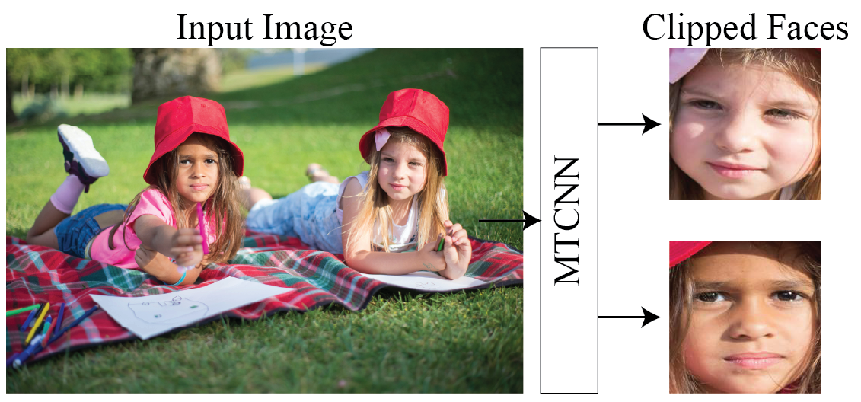
Supplemental Figure 2. Preprocessing Imagery for the Age Multimodal Deep Learning Model. Abbreviations: MTCNN – multi-task cascaded convolutional neural network. Example input image is public domain, not from social media.
Supplemental Table 4. City Shortnames Used in Named Entity Recognition
City | City cont'd | City cont'd
alburquerque | greensboro | oklahoma city
alrington | hartford | omaha
anaheim | henderson | orlando
anchorage | honolulu | philadelphia
atlanta | houston | phoenix
aurora | huntsville | pittsburgh
austin | indianapolis | plano
bakersfield | irvine | portland
baltimore | jackson | providence
baton rouge | jacksonville | raleigh
billings | kansas city | riverside
boise | las vegas | sacramento
boston | lexington | saint paul
bridgeport | lincoln | salt lake city
charleston | little rock | san antonio
charlotte | long beach | san diego
chicago | los angeles | san fransisco
cincinnati | louisville | san jose
cleveland | madison | santa ana
colorado springs | manchester | seattle
columbus | memphis | sioux falls
corpus christi | mesa | stockton
dallas | miami | tallahassee
denver | milwaukee | tampa
des moines | minneapolis | topeka
detroit | montgomery | tucson
durham | nashville | tulsa
el paso | new orleans | virginia beach
fargo | new york city | wichita
fort worth | newark
fresno | oakland

Supplemental Table 5. Composition of User Profile Arrays
Array Index | Description
0 | percentage of posts about children (any age group)
1 | percentage of posts about babies/infants
2 | percentage of posts about toddlers
3 | percentage of posts about elementary school children
4 | percentage of posts about middle school children
5 | percentage of posts about high school children
6 | percentage of posts about parks
7 | percentage of posts about home
8 | percentage of posts about schools
9 | percentage of posts about neighborhoods
10 | percentage of posts about daycare
11 | percentage of posts about cognitive health symptoms/outcomes
12 | percentage of posts about emotional/social health symptoms/outcomes
13 | percentage of posts about physical health symptoms/outcomes

Supplemental Table 6. Percent Positive Labels in Labeled Datasets, Stratified by Keyword.
Age |  |  | Place |  |  | Health |  |  | Health (cont’d)
Keyword | Count (n) | Positive (%) | Keyword | Count (n) | Positive (%) | Keyword | Count (n) | Positive (%) | Keyword | Count (n) | Positive (%)
anklebiter | 115 | 5.22 | academy | 183 | 14.21 | accident | 102 | 3.92 | knowledge | 132 | 11.36
babe | 2719 | 3.60 | after school care | 54 | 35.19 | activity | 128 | 9.38 | learn | 132 | 9.85
babies | 2338 | 35.41 | apartment | 140 | 2.14 | ADD | 149 | 4.03 | learning | 158 | 19.62
baby | 2514 | 14.24 | backyard | 192 | 6.25 | aerobic | 65 | 6.15 | leukemia | 312 | 47.12
bambino | 2223 | 6.66 | center-based care | 138 | 23.19 | allergy | 267 | 5.99 | lungs | 112 | 7.14
boy | 2448 | 8.01 | childcare | 140 | 40.00 | arithmetic | 63 | 7.94 | memory | 142 | 5.63
brat | 2526 | 8.79 | community | 182 | 12.64 | asthma | 125 | 12.80 | mind | 127 | 2.36
bundle of joy | 2757 | 48.20 | condo | 178 | 1.12 | attention | 120 | 6.67 | muscle | 158 | 9.49
child | 2353 | 37.99 | court | 146 | 5.48 | bone | 126 | 4.76 | nanny | 153 | 36.60
childhood | 2828 | 6.36 | day camp | 147 | 37.41 | brain | 133 | 10.53 | nutrition | 155 | 14.84
children | 2396 | 66.32 | day nursery | 20 | 30.00 | breathe | 132 | 6.06 | obesity | 176 | 31.25
girl | 2379 | 5.88 | daycare | 163 | 57.67 | cancer | 344 | 19.48 | physical | 107 | 9.35
high schooler | 2119 | 65.88 | digs | 160 | 6.88 | cardiovascular | 129 | 3.88 | physical | 109 | 3.67
in elementary school | 2335 | 14.22 | early childhood center | 75 | 24.00 | cerebral palsy | 104 | 26.92 | play area | 123 | 47.15
infant | 2328 | 52.36 | early education | 146 | 36.30 | cognition | 43 | 4.65 | playing | 136 | 9.56
juvenille | 307 | 8.47 | elementary | 145 | 34.48 | condominium | 104 | 0.00 | posture | 273 | 4.76
kid | 2359 | 28.66 | field | 159 | 9.43 | coordination | 259 | 8.49 | problem | 109 | 6.42
kiddie | 2379 | 15.64 | front yard | 217 | 6.45 | cough | 124 | 9.68 | rash | 277 | 9.75
little one | 2787 | 25.48 | greenspace | 13 | 23.08 | creativity | 182 | 8.79 | read | 161 | 7.45
middle schooler | 2113 | 59.16 | home | 144 | 2.78 | critical | 140 | 7.86 | reason | 127 | 8.66
minor | 2329 | 4.25 | house | 152 | 6.58 | curriculum | 122 | 22.95 | recreational area | 10 | 0.00
neonate | 264 | 58.71 | jungle gym | 91 | 41.76 | deficit | 139 | 2.16 | running | 134 | 7.46
newborn | 2609 | 62.17 | kindergarten | 192 | 45.83 | dehydration | 234 | 3.85 | SIDS | 146 | 27.40
pediatric | 2564 | 24.69 | learning center | 142 | 15.49 | delay | 110 | 8.18 | smart | 126 | 10.32
preemie | 1589 | 58.46 | merry go round | 108 | 3.70 | developmental | 107 | 22.43 | solving | 141 | 14.18
preschooler | 1783 | 71.45 | middle | 158 | 20.25 | diabetes | 141 | 12.77 | thinking | 107 | 7.48
preterm | 1119 | 27.52 | nannie | 52 | 13.46 | diet | 125 | 0.00 | understand | 120 | 4.17
pupil | 2217 | 6.72 | neighbor | 149 | 11.41 | disability | 140 | 17.14 | weight | 127 | 9.45
rug rat | 437 | 7.78 | neighborhood | 176 | 9.66 | disorder | 123 | 11.38 | wheeze | 45 | 0.00
teenager | 2203 | 37.90 | nursery | 153 | 23.53 | dizzy | 120 | 1.67 | write | 125 | 11.20
toddler | 2523 | 61.20 | nursery school | 17 | 41.18 | early education center | 14 | 21.43
tot | 2628 | 8.68 | pad | 156 | 4.49 | early learning center | 42 | 14.29
tyke | 1892 | 11.95 | park | 130 | 10.00 | education center | 125 | 7.20
youngling | 1185 | 9.03 | parkland | 141 | 14.18 | exhaustion | 138 | 7.25
youth | 2787 | 34.30 | playground | 156 | 33.97 | flexibility | 300 | 6.33
 |  |  | prekindergarten | 10 | 20.00 | food | 127 | 4.72
 |  |  | preschool | 185 | 56.22 | heart | 138 | 7.97
 |  |  | rental | 151 | 1.32 | heat | 124 | 4.84
 |  |  | residence | 145 | 2.07 | heat exhaustion | 22 | 0.00
 |  |  | school | 146 | 43.84 | home-based care | 142 | 16.90
 |  |  | schoolhouse | 72 | 9.72 | hyperactivity | 17 | 41.18
 |  |  | schoolyard | 54 | 20.37 | imagination | 131 | 7.63
 |  |  | seesaw | 40 | 5.00 | injury | 126 | 2.38
 |  |  | swings | 145 | 4.83 | intelligence | 114 | 8.77
 |  |  | townhouse | 133 | 1.50 | intelligent | 107 | 5.61

Positive corresponds to the percentage of posts which have a positive label associated with the keyword (e.g. the keyword baby is associated with the label baby/infant).

Supplemental Table 7. Student Labeling QA Accuracy for Summer 2022.
Summer Cohort
 |  | Negative QA |  | Positive QA |  | Label |  | Domain
Domain | Label | Accuracy (%) | n | Accuracy (%) | n | Accuracy (%) | n | Accuracy (%) | n
location | school | 83.6 | 73 | 50.6 | 81 | 66.2 | 154 | 75.7 | 596
location | home | 73.2 | 71 | 90.3 | 72 | 81.8 | 143
location | daycare | 55.4 | 74 | 79.2 | 77 | 67.5 | 151
location | park | 97.3 | 75 | 78.1 | 73 | 87.8 | 148
age | baby | 100.0 | 78 | 66.7 | 72 | 84.0 | 150 | 79.6 | 754
age | toddler | 77.5 | 80 | 89.9 | 79 | 83.6 | 159
age | elementary school | 81.2 | 69 | 79.5 | 73 | 80.3 | 142
age | middle school | 78.9 | 71 | 64.6 | 82 | 71.2 | 153
age | high school | 73.4 | 79 | 84.5 | 71 | 78.7 | 150
health | physical | 100.0 | 10 | 100.0 | 6 | 100.0 | 16 | 77.9 | 321
health | emotional | 58.4 | 77 | 81.4 | 86 | 70.6 | 163
health | cognitive | 95.8 | 71 | 71.8 | 71 | 83.8 | 142
overall |  | 79.7 | 828 | 76.0 | 843 | 77.8 | 1671
Negative QA: correct response for the QA post was negative for the designated label. Positive QA: correct response for the QA post was positive for the designated label.
legend
>= 80% correct
>=70% correct
< 70% correct

Supplemental Table 8. Student Labeling QA Accuracy for Fall 2022.
Fall Cohort
 |  | Negative QA |  | Positive QA |  | Label |  | Domain
Domain | Label | Accuracy (%) | n | Accuracy (%) | n | Accuracy (%) | n | Accuracy (%) | n
location | school | 75 | 138 | 56 | 137 | 66 | 275 | 70.0 | 1087
location | home | 71 | 133 | 76 | 140 | 74 | 273
location | daycare | 44 | 135 | 68 | 134 | 56 | 269
location | park | 92 | 136 | 78 | 134 | 85 | 270
age | baby | 100 | 114 | 64 | 112 | 82 | 226 | 80.4 | 1138
age | toddler | 78 | 113 | 89 | 116 | 84 | 229
age | elementary school | 87 | 115 | 80 | 113 | 84 | 228
age | middle school | 83 | 115 | 64 | 112 | 74 | 227
age | high school | 75 | 117 | 83 | 111 | 79 | 228
health | physical | 91 | 11 | 100 | 13 | 96 | 24 | 76.6 | 518
health | emotional | 67 | 124 | 69 | 125 | 68 | 249
health | cognitive | 92 | 122 | 75 | 123 | 83 | 245
overall |  | 80 | 1373 | 76 | 1370 | 78 | 2743
Negative QA: correct response for the QA post was negative for the designated label. Positive QA: correct response for the QA post was positive for the designated label.

legend
>= 80% correct
>=70% correct
< 70% correct

Supplemental Table 9. Student Labeling QA Accuracy, Stratified by Student, Label, and Model.
Negative QA: Correct response for QA post would be negative. Positive QA: Correct response for QA post would be positive.
Supplemental Table 10. Validation Dataset Performance Metrics for Age Deep Learning Models.
Multimodal Model
Hybrid Model | TP | TN | FP | FN | Accuracy | Sensitivity | Specificity
baby | 33 | 351 | 11 | 15 | 93.7 | 68.8 | 95.9
toddler | 31 | 340 | 8 | 31 | 90.5 | 50.0 | 91.6
elementary | 16 | 349 | 9 | 36 | 89.0 | 30.8 | 90.6
middle | 4 | 386 | 2 | 18 | 95.1 | 18.2 | 95.5
high | 16 | 367 | 7 | 20 | 93.4 | 44.4 | 94.8
general | 181 | 157 | 35 | 37 | 82.4 | 83.0 | 80.9
all | 281 | 1950 | 72 | 157 | 90.7 | 64.2 | 92.5
Text Model (posts with imagery)
category | TP | TN | FP | FN | Accuracy | Sensitivity | Specificity
baby | 26 | 355 | 7 | 22 | 92.9 | 54.2 | 94.2
toddler | 14 | 344 | 4 | 48 | 87.3 | 22.6 | 87.8
elementary | 5 | 357 | 1 | 47 | 88.3 | 9.6 | 88.4
middle | 3 | 388 | 0 | 19 | 95.4 | 13.6 | 95.3
high | 14 | 370 | 4 | 22 | 93.7 | 38.9 | 94.4
general | 150 | 160 | 32 | 68 | 75.6 | 68.8 | 70.2
all | 212 | 1974 | 48 | 226 | 88.9 | 48.4 | 89.7
Text Model (all validation posts)
category | TP | TN | FP | FN | Accuracy | Sensitivity | Specificity
baby | 242 | 4539 | 85 | 134 | 95.6 | 64.4 | 97.1
toddler | 143 | 4729 | 37 | 91 | 97.4 | 61.1 | 98.1
elementary | 20 | 4877 | 14 | 89 | 97.9 | 18.3 | 98.2
middle | 65 | 4860 | 19 | 56 | 98.5 | 53.7 | 98.9
high | 108 | 4770 | 36 | 86 | 97.6 | 55.7 | 98.2
general | 952 | 3308 | 364 | 376 | 85.2 | 71.7 | 89.8
all | 1530 | 27083 | 555 | 832 | 95.4 | 64.8 | 97.0
Abbreviations: TP – true positive, FP – false positive, TN – true negative, FN – false negative.

Supplemental Table 11. Validation Dataset Performance Metrics for Place Deep Learning Models.
Multimodal Model
category | TP | TN | FP | FN | Accuracy | Sensitivity | Specificity
childcare/daycare | 17 | 950 | 5 | 18 | 97.7 | 48.6 | 98.1
park/playground | 32 | 930 | 7 | 21 | 97.2 | 60.4 | 97.8
home | 147 | 712 | 53 | 78 | 86.8 | 65.3 | 90.1
school | 95 | 814 | 35 | 46 | 91.8 | 67.4 | 94.7
neighborhood | 7 | 964 | 5 | 14 | 98.1 | 33.3 | 98.6
indoor | 363 | 407 | 118 | 102 | 77.8 | 78.1 | 80.0
outdoor | 245 | 605 | 64 | 76 | 85.9 | 76.3 | 88.8
all | 906 | 5382 | 287 | 355 | 90.7 | 71.8 | 93.8
Text Model (posts with imagery)
category | TP | TN | FP | FN | Accuracy | Sensitivity | Specificity
childcare/daycare | 13 | 950 | 5 | 22 | 97.3 | 37.1 | 97.7
park/playground | 30 | 931 | 6 | 23 | 97.1 | 56.6 | 97.6
home | 127 | 727 | 38 | 98 | 86.3 | 56.4 | 88.1
school | 92 | 809 | 40 | 49 | 91.0 | 65.2 | 94.3
neighborhood | 9 | 960 | 9 | 12 | 97.9 | 42.9 | 98.8
indoor | 317 | 376 | 149 | 148 | 70.0 | 68.2 | 71.8
outdoor | 202 | 605 | 64 | 119 | 81.5 | 62.9 | 83.6
all | 790 | 5358 | 311 | 471 | 88.7 | 62.6 | 91.9
Text Model - All Tweets
category | TP | TN | FP | FN | Accuracy | Sensitivity | Specificity
childcare/daycare | 82 | 4797 | 44 | 77 | 97.6 | 51.6 | 98.4
park/playground | 123 | 4764 | 37 | 76 | 97.7 | 61.8 | 98.4
home | 508 | 4094 | 214 | 184 | 92.0 | 73.4 | 95.7
school | 374 | 4273 | 167 | 186 | 92.9 | 66.8 | 95.8
neighborhood | 40 | 4865 | 23 | 72 | 98.1 | 35.7 | 98.5
indoor | 1239 | 2835 | 488 | 438 | 81.5 | 73.9 | 86.6
outdoor | 539 | 3966 | 226 | 269 | 90.1 | 66.7 | 93.6
all | 2905 | 29594 | 1199 | 1302 | 92.9 | 69.1 | 95.8
Abbreviations: TP – true positive, FP – false positive, TN – true negative, FN – false negative.

Supplemental Table 12. Validation Dataset Performance Metrics for Health Deep Learning Models.
Multimodal Model
category | TP | TN | FP | FN | Accuracy | Sensitivity | Specificity
cognitive health | 0 | 753 | 0 | 28 | 96.4 | 0.0 | 96.4
emotional/social | 0 | 580 | 0 | 201 | 74.3 | 0.0 | 74.3
physical health | 134 | 1 | 645 | 1 | 17.3 | 99.3 | 50.0
positive impact | 171 | 103 | 474 | 33 | 35.1 | 83.8 | 75.7
negative impact | 0 | 651 | 1 | 129 | 83.4 | 0.0 | 83.5
all | 305 | 2088 | 1120 | 392 | 61.3 | 43.8 | 84.2
Text Model - Image Only Tweets
category | TP | TN | FP | FN | Accuracy | Sensitivity | Specificity
cognitive health | 4 | 749 | 4 | 24 | 96.4 | 14.3 | 96.9
emotional/social | 72 | 538 | 42 | 129 | 78.1 | 35.8 | 80.7
physical health | 100 | 617 | 29 | 35 | 91.8 | 74.1 | 94.6
positive impact | 87 | 533 | 44 | 117 | 79.4 | 42.6 | 82.0
negative impact | 88 | 610 | 42 | 41 | 89.4 | 68.2 | 93.7
all | 351 | 3047 | 161 | 346 | 87.0 | 50.4 | 89.8
Text Model - All Tweets
category | TP | TN | FP | FN | Accuracy | Sensitivity | Specificity
cognitive health | 73 | 4276 | 29 | 172 | 95.6 | 29.8 | 96.1
emotional/social | 287 | 3733 | 231 | 709 | 81.0 | 28.8 | 84.0
physical health | 541 | 3944 | 232 | 283 | 89.7 | 65.7 | 93.3
positive impact | 211 | 4090 | 151 | 548 | 86.0 | 27.8 | 88.2
negative impact | 666 | 3595 | 328 | 411 | 85.2 | 61.8 | 89.7
all | 1778 | 19638 | 971 | 2123 | 87.4 | 45.6 | 90.2
Abbreviations: TP – true positive, FP – false positive, TN – true negative, FN – false negative.

Supplemental Table 13. Number of Georeferenced Posts, Stratified by Georeferencing Method.
 | Georeferencing method
 | all* | city full name | city short name | state | airport | geofences | pois
authors (n) | 7491457 | 6513300 | 934193 | 1487049 | 43964 | NA | NA
posts (n) | 350701338 | 1.65E+08 | 27458520 | 52648611 | 1335085 | 334531893 | 2447749
age groups
child (n) | 16354337 | 7983583 | 1159529 | 2698158 | 48333 | 13602542 | 242357
baby (n) | 922300 | 415724 | 63823 | 154010 | 3376 | 794693 | 5680
toddler (n) | 457847 | 229247 | 38275 | 73999 | 1367 | 383981 | 4119
elementary (n) | 816581 | 448951 | 59974 | 130910 | 1679 | 641033 | 25525
middle school (n) | 361787 | 188674 | 26301 | 52682 | 955 | 294678 | 9273
high school (n) | 1435654 | 711439 | 93915 | 193599 | 4575 | 1195107 | 30387
places
home (n) | 24287884 | 10323947 | 1576656 | 3064491 | 102551 | 21550586 | 108166
school (n) | 10869357 | 4929584 | 611045 | 1303164 | 40919 | 9365179 | 186096
daycare (n) | 73206 | 35487 | 5505 | 9455 | 224 | 63704 | 972
park (n) | 3284374 | 1702873 | 346843 | 418347 | 8985 | 2622243 | 66226
neighborhood(n) | 905586 | 451138 | 123095 | 126629 | 2445 | 787560 | 6106
outdoors (n) | 20167349 | 11478305 | 2292196 | 2612933 | 36783 | 16364629 | 390881
indoors (n) | 54171594 | 24450611 | 3915461 | 6564597 | 200705 | 47396256 | 774887
health
emotional/social | 50543764 | 19844047 | 2767661 | 6460240 | 232225 | 45112149 | 156368
cognitive (n) | 275047 | 141351 | 22823 | 59598 | 616 | 227137 | 2390
physical (n) | 10187219 | 4796625 | 770115 | 1644460 | 33285 | 8737410 | 41819
positive (n) | 28185006 | 11299659 | 1543254 | 3528745 | 119770 | 25041683 | 139427
negative (n) | 28487173 | 11842651 | 1789952 | 4112444 | 126312 | 25094985 | 56001
* all posts georeferenced at the city spatial extent or finer, does not include posts georeferenced to state.

Supplemental Table 14. Community Summary Statistics, Stratified by Community Size.
 | Community Size (n users)
 | all (n=19346) |  | 1 to 10 (n=630) |  | 11 to 100 (n=11466) |  | 101 to 1000 (n=6089) |  | 1000+ (n=1161)
 | mean | sd | mean | sd | mean | sd | mean | sd | mean | sd
posts | 19624.2 | 70960.5 | 1917.2 | 2345.4 | 3185.2 | 4023.5 | 16396.7 | 18515.4 | 208510.1 | 208343.0
users | 275.8 | 825.1 | 7.6 | 2.0 | 47.8 | 23.5 | 296.4 | 211.2 | 2565.4 | 2304.8
interaction | 5521.0 | 16840.9 | 271.2 | 244.8 | 1281.0 | 963.0 | 6055.4 | 6342.9 | 47440.2 | 50562.0
interactions/user | 25.8 | 17.9 | 36.8 | 33.0 | 28.1 | 18.0 | 21.7 | 14.8 | 18.4 | 11.0
age groups
child | 973.9 | 3096.3 | 183.7 | 152.0 | 206.5 | 191.9 | 866.6 | 940.4 | 9544.4 | 8667.4
baby | 52.2 | 177.3 | 11.7 | 20.1 | 11.4 | 13.4 | 47.2 | 58.5 | 503.1 | 532.2
toddler | 26.0 | 94.7 | 5.0 | 12.7 | 5.0 | 6.8 | 22.1 | 27.0 | 265.3 | 288.5
elementary | 49.7 | 221.7 | 5.9 | 9.8 | 10.3 | 14.5 | 41.4 | 75.4 | 507.1 | 749.1
middle school | 20.3 | 82.0 | 2.7 | 4.9 | 3.3 | 7.0 | 16.1 | 25.8 | 219.0 | 256.2
high school | 79.6 | 295.9 | 8.8 | 18.9 | 10.7 | 14.1 | 66.7 | 96.4 | 866.3 | 859.6
places
home | 1223.5 | 5348.3 | 82.2 | 239.8 | 130.8 | 300.2 | 1019.5 | 1865.2 | 13704.2 | 17006.3
school | 581.8 | 2404.0 | 44.7 | 116.8 | 61.0 | 93.1 | 472.1 | 799.6 | 6591.4 | 7340.4
daycare | 3.7 | 19.6 | 0.7 | 4.1 | 0.5 | 7.1 | 2.6 | 5.5 | 43.0 | 63.8
park | 156.3 | 833.4 | 9.7 | 34.3 | 18.0 | 115.6 | 114.6 | 260.9 | 1820.0 | 2848.4
neighborhood | 44.1 | 424.0 | 2.5 | 8.2 | 7.4 | 271.9 | 26.9 | 100.8 | 518.4 | 1404.8
outdoors | 959.2 | 7510.9 | 58.6 | 263.1 | 132.9 | 3472.2 | 587.4 | 2451.4 | 11558.1 | 25878.6
indoors | 2792.1 | 15095.0 | 215.2 | 1106.7 | 280.9 | 352.3 | 2102.3 | 3334.6 | 32609.3 | 52739.1
health symptoms/outcomes
emotional/social | 2677.4 | 12147.3 | 154.9 | 208.0 | 288.0 | 375.2 | 2372.8 | 3886.3 | 29241.8 | 40167.6
cognitive | 17.4 | 87.2 | 4.1 | 10.8 | 4.9 | 15.1 | 17.3 | 60.4 | 148.8 | 294.1
physical | 590.3 | 2047.4 | 91.0 | 123.9 | 124.2 | 186.7 | 529.4 | 731.7 | 5783.1 | 6119.6
positive | 1481.9 | 6608.7 | 63.8 | 118.6 | 138.3 | 212.6 | 1312.6 | 2208.8 | 16408.2 | 21453.0
negative | 1579.8 | 6147.8 | 182.0 | 190.4 | 266.5 | 273.4 | 1427.8 | 1862.1 | 16106.4 | 19542.6

